Steps to Setup:

1. Import the Project as gradle and run the Gradlew command in folder.
2. Please add the .json file location in the service class else file not found exception will be thrown which will handled and application error is retured.
3. Start the server web starts on 3000 port and Backend starts on 8002

Attached postman collection to test it.

1. Frone end please run npm install and start the web application with npm start command.
2. Attached postman collection for reference.

File location variable :-

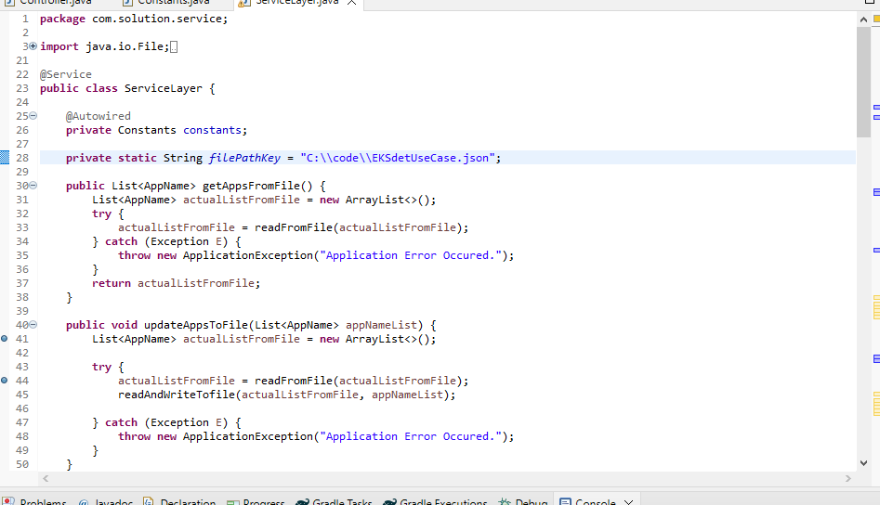

Back End Test evidence:

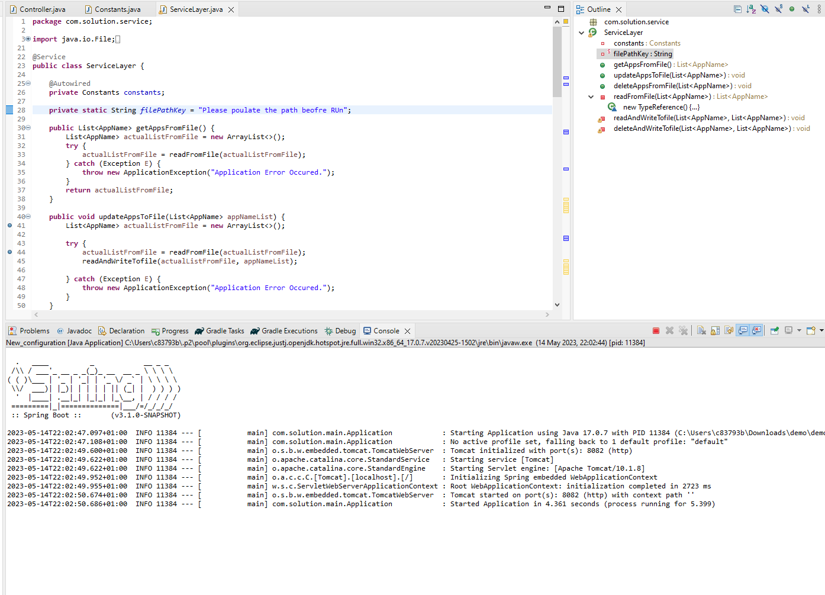

GET :-

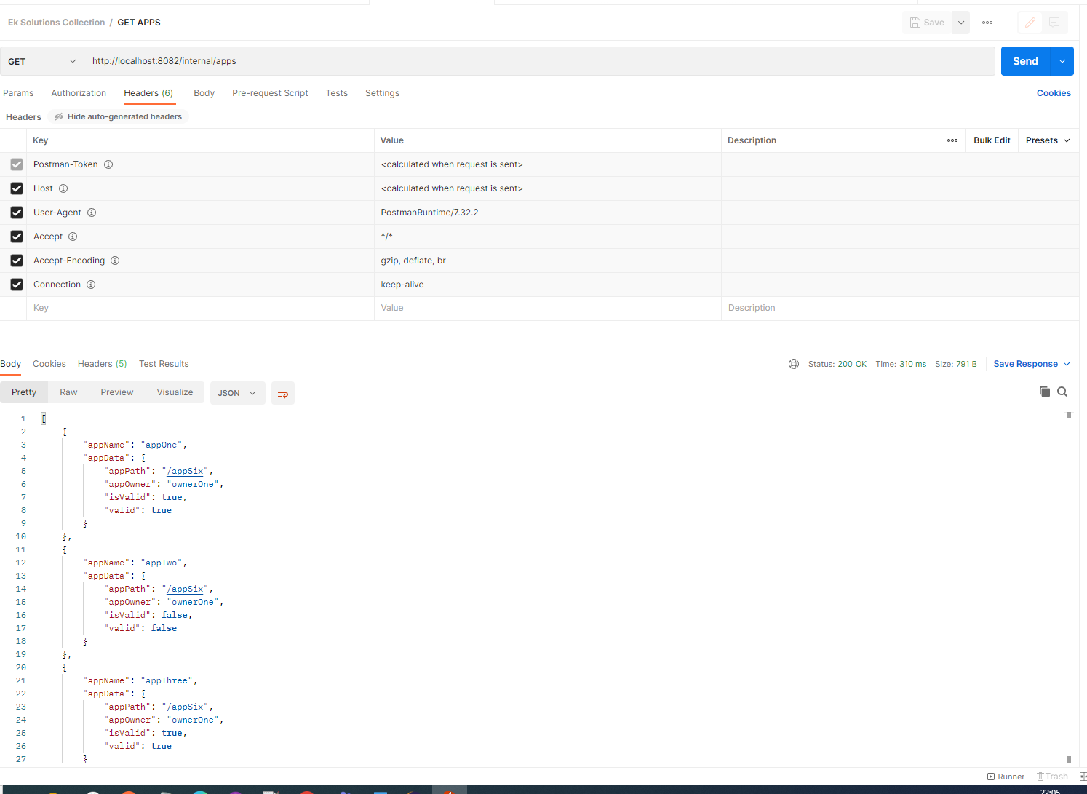

Update:-

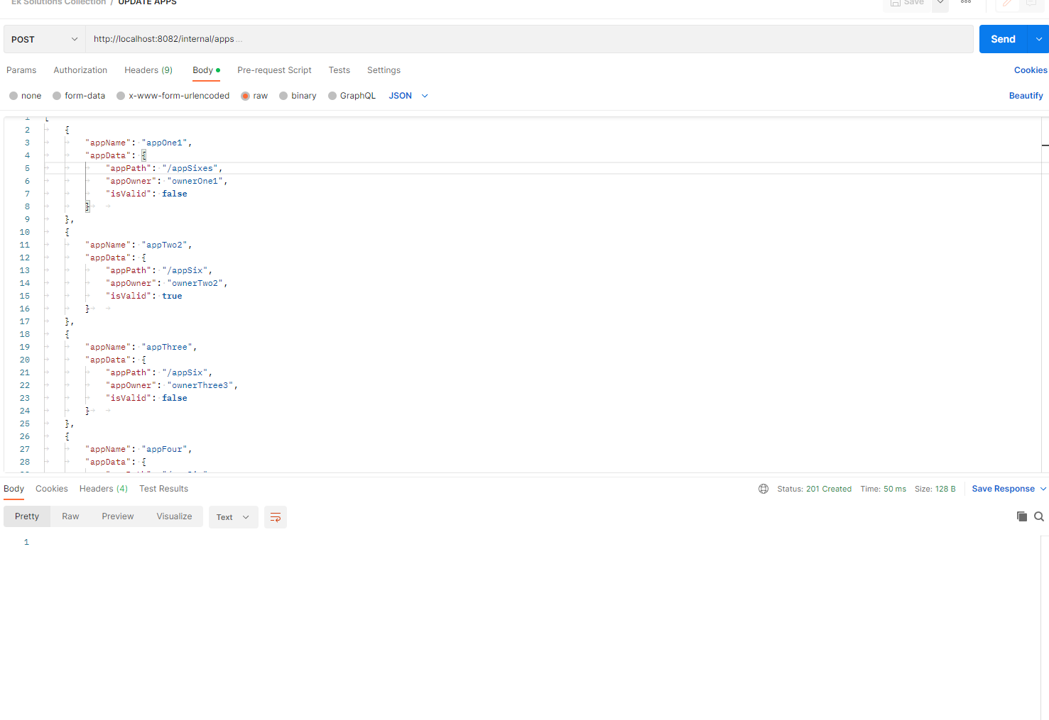

Updated

values:-

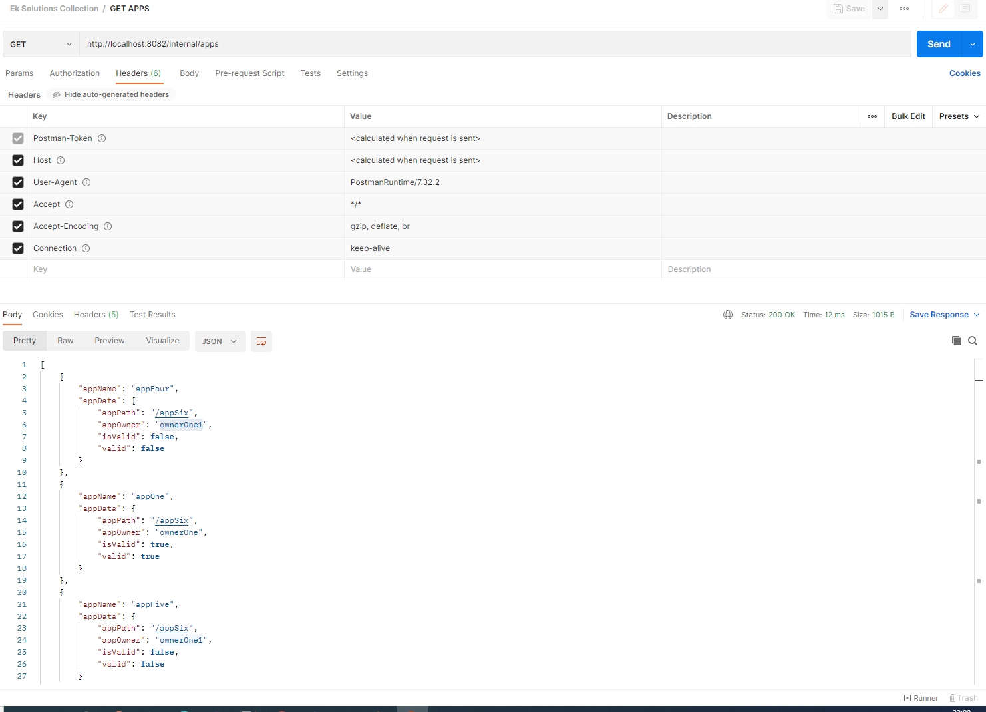

Delete:-

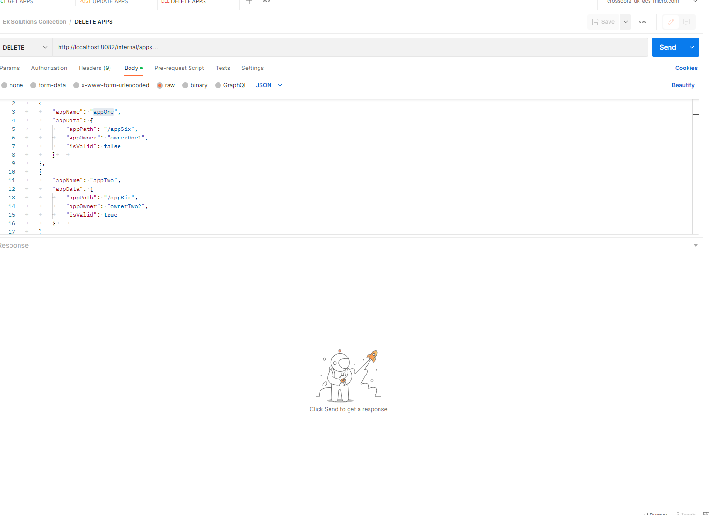

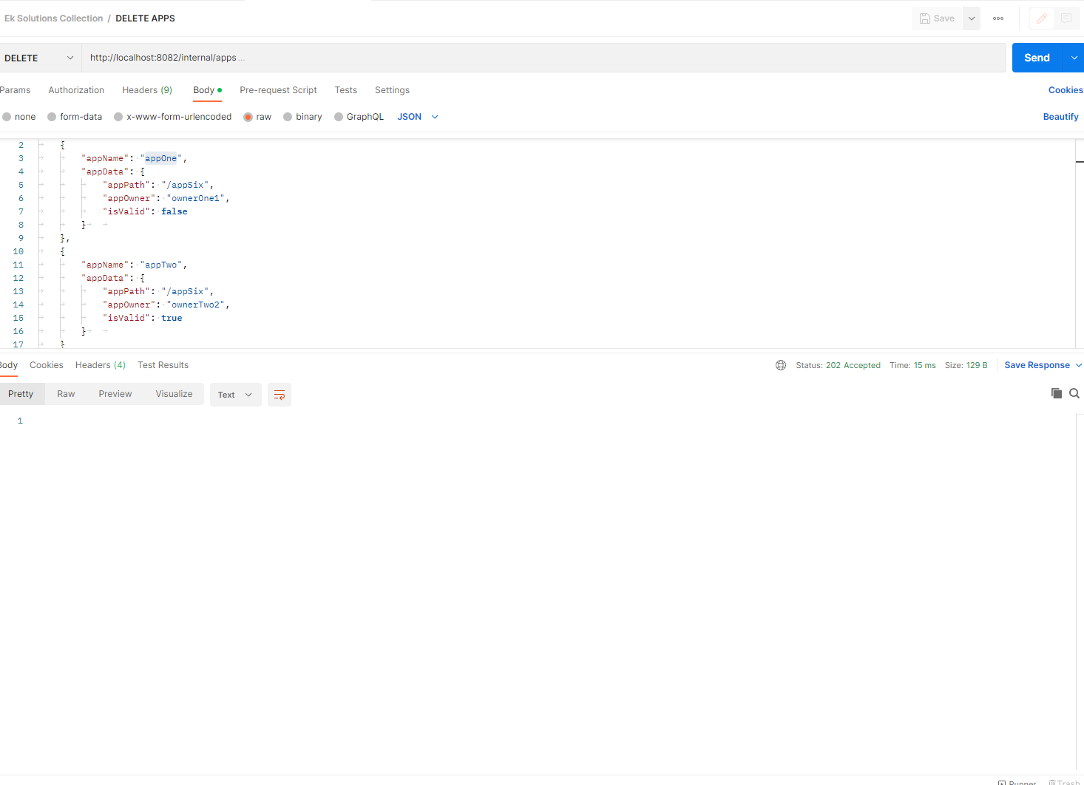

Deleted Values:-

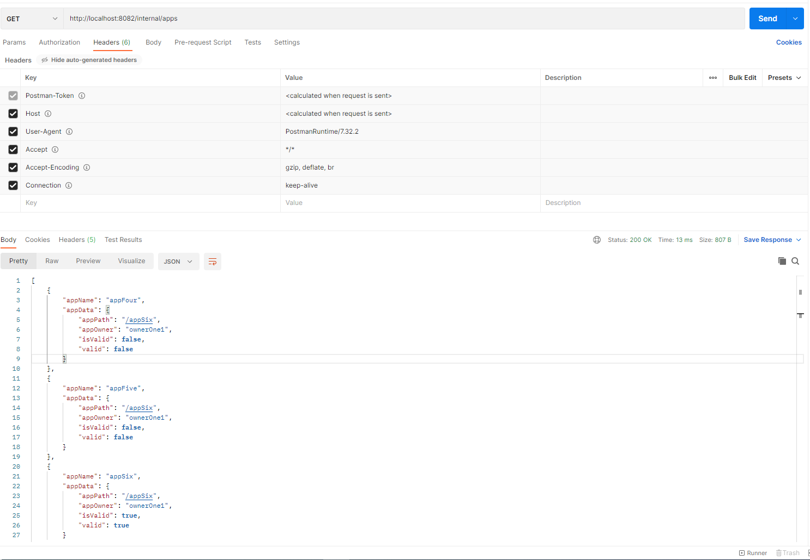

Frone end Test evidences (completed version) :- (Pages design pending)

